

**Information Search and Analysis Skills**

**(ISAS)**

**“Analysis E-Business on Netflix”**

1. Ferdian Adi Pratama

2. Mochammad Rifaldi

3. Novian Nanda Nur M.

Class : 2NAP2

Faculty : Ms. Nur Hildayanti Utami

Continuing Education Program Centesaar for Computing and Information Technology

Faculty of Engineering, University of Indonesia

# **PREFACE**

With the name of Allah Most Gracious Most Merciful, we again panjatkan puja and praise over his presence, which has been part of his grace, hidayat, and inayah him so that ISAS Report about Netflix can be completed which God willing useful for all of us.

ISAS report has been in rows with its fullest and got help from various parties and the source so that it can facilitate the creation of this report. And especially to Mrs Nur Hildayanti Utami. Who has provided guidance in making these ISAS report.

The report is organized so that readers can find out about the service to watch the movie/Video overseas as well as domestic online, presented based on an analysis of the different sources of information, references, and other resources. This report was prepared with a variety of obstacles. Whether it is coming from the internal and external problems. But with great patience and especially the help of Almighty God finally reports ISAS can be resolved.

ISAS report this may be able to provide a wider insight and thought-provoking contribution to the readers especially-CCIT FTUI students. This report is probably still a lot of shortcomings and arguably hasn't been perfect. To that end, to give input for the sake of supervising lecturer improvement making this report in the days to come and expect criticism and suggestions from readers.

Depok, .... March 2018

Writers

# **TABLE OF CONTENTS**

PREFACE i

TABLE OF CONTENTS ii

LIST OF PICTURES iv

LIST OF TABLES iv

CHAPTER I 1

INTRODUCTIONS 1

**I. 1** **Background** 1

**I. 2** **Purpose of Writing** 1

**I. 3** **Problem Domain** 1

**I. 4** **Learning Methodology** 2

**I. 4. 1 Method Library** 2

**I. 4. 2 Discussion** 2

**I.5 Writing Framework** 2

CHAPTER II 4

BASIC THEORY 4

**II.1 The Definition of E-Business** 4

**II.2 Type of E-Business** 4

**II.3 The Definition of Streaming Media** 5

**II.4 The Definition of Video on Demand** 5

II.5 Revenue model 6

**II.6 History of Netflix** 6

CHAPTER III 9

PROBLEM ANALYSIS 9

III.1 The Capability of Netflix 9

III.2 Features of Netflix 9

III.3 The Comparison Between Netflix and Iflix 11

III.4 Target Customer 12

III.5 Revenue Model of Netflix 12

III.6 Advantages and Disadvantages of Netflix 13

CHAPTER IV 14

CONCLUSION AND SUGGESTION 14

IV.1 Conclusion 14

IV.2 Suggestion 14

Bibliography 15

LIST OF PICTURES

Figure 3. 1 (Ref: https:// wccftech.com/netflix-google-play-account-billing-long/ ) 9

Figure 3. 2 (Ref : https://www.feedough.com/how-does-netflix-make-money/ ) 12

Figure 3. 3 (Ref:https: //www.statista.com/statistics/272545/annual-revenue-of-netflix/ ) 13

# **LIST OF TABLES**

Table 3. 1 Comparison Netflix & Iflix 11

Table 3. 2 Advantages dan Disadvantages Netflix 13

# **CHAPTER I**

# **INTRODUCTIONS**

## **Background**

The current technological development has been developing rapidly. Formerly the public rent a movie or DVD disks in stores, with a short loan period and fines must be paid when a late return.Therefore the community feel saturated with this kind of rental system. The thing that causes the drop in DVD sales by up to 14%.

Therefore it takes her a practical service to support high mobility.This is the cause of the community began to switch to streaming video service.This service can be accessed anytime, anywhere, and can be enjoyed by users in a long period of time. Although in its use should do the existing requirements in the service.

To answer these problems then created the streaming video service called Netflix.This service can be accessed online across all mobile devices, this service is also available for offline if the user is already subscribed each month. This service also has a lot of interesting content in terms of video quality. This service is also available a wide choice of subscription packages at an affordable price.

.

## **Purpose of Writing**

As for the purpose of writing this ISAS are:

* Describes Definition E-Business
* Describes Type of E-Business
* Describes Definition of Neflix
* Describes History of Netflix

## **Problem Domain**

As for the problem of writing this ISAS are

* The Capability of Netflix
* Features of Netflix
* The Comparison Between Netflix & Iflix
* Target Customer
* Business Flow of Netflix
* Advantages & Disadvantages Netflix

## **Learning Methodology**

### **I. 4. 1 Method Library**

The method used in writing this ISAS paper is by searching for information from reference sources contained on the online sites related to the information contained in this ISAS discussion.

### **I. 4. 2 Discussion**

Obtain complete data by collecting it through various sources of information available on the internet for the purpose of making ISAS papers.

## **I.5 Writing Framework**

**Chapter I Introduction**

* Background
* Writing Objective
* Problem Domain
* Writing Methodology
* Writing Framework

**Chapter II Basic Theory**

* Definition of E-Business
* Type of E-Business
* Definition of Netflix
* History of Netflix

**Chapter III Problem Analysis**

* The Capability of Netflix
* Features of Netflix
* The Comparison Between Netflix & Iflix
* Target Customer
* Business Flow of Netflix
* Advantages & Disadvantages Netflix

**Chapter IV Conclusion And Suggestion**

* Conclusion
* Suggestions

# **CHAPTER II**

# **BASIC THEORY**

## **II.1 The Definition of E-Business**

Electronic business (e-business) refers to the use of the Web, Internet, intranets, extranets or some combination thereof to conduct business. E-business is similar to e-commerce, but it goes beyond the simple buying and selling of products and services online. E-business includes a much wider range of businesses processes, such as supply chain management, electronic order processing and customer relationship management. E-business processes, therefore, can help companies to operate more effectively and efficiently.[1]

## **II.2 Type of E-Business**

When organizations go online, they have to decide which e-business models best suit their goals. A business model is defined as the organization of product, service and information flows, and the source of revenues and benefits for suppliers and customers. The concept of e-business model is the same but used in the online presence.

E-Business models can generally categorized in following categories :

* Business - to - Business (B2B)

Business to business, also called B to B or B2B, is a type of transaction that exists between businesses, such as one involving a manufacturer and wholesaler, or a wholesaler and a retailer. Business to business refers to business that is conducted between companies, rather than between a company and individual consumers.

* Business - to - Consumer (B2C)

Business to consumer (B2C) is business or transactions conducted directly between a company and consumers who are the end-users of its products or services.

* Consumer - to - Consumer (C2C)

Customer to customer (C2C) is a [business model](https://www.investopedia.com/terms/b/businessmodel.asp) where by customers can trade with each other, typically, in the online environment. Two implementations of C2C markets are auctions and classified advertisements. C2C marketing has soared in popularity with the arrival of the internet, and companies such as eBay and OLX.

* Consumer - to - Business (C2B)

Consumer-to-business (C2B) is a business model where an end user or consumer makes a product or service that an organization uses to complete a business process or gain competitive advantage. The C2B methodology completely transposes the traditional business-to-consumer (B2C) model, where a business produces services and products for consumer consumption.

## **II.3 The Definition of Streaming Media**

Streaming media is the method used to deliver multimedia elements - usually video or audio - from a data streaming service provider to an end user. It uses basic HTTP, TCP/IP and HTML protocols.

Streaming delivers media as a serial, steady stream. Unlike other download methods, where data order is not important, streaming media is sent/received according to availability. An example is P2P sharing, such as torrent, where streaming media must be delivered in the correct order.

## **II.4 The Definition of Video on Demand**

Video on demand (VOD) is a system that allows users to select and watch video content of their choice on their TVs or computers. Video on demand is one of the dynamic features offered by Internet Protocol TV. VOD provides users with a menu of available videos from which to choose. The video data is transmitted via Real-Time Streaming Protocol.

II.5 Revenue model

A key component of the business model is the revenue model, which is a framework for generating revenues. It identifies which revenue source to pursue, what value to offer, how to price the value, and who pays for the value. It is a key component of a company's business model. It primarily identifies what product or service will be created in order to generate revenues and the ways in which the product or service will be sold.

## **II.6 History of Netflix**

Netflix, Inc. operates as an Internet subscription service company, which provides subscription service streaming movies and TV episodes over the Internet and sending DVDs by mail. The company operates its business through the following segments: Domestic streaming, International streaming and Domestic DVD. Netflix obtains content from various studios and other content providers through fixed-fee licenses, revenue sharing agreements and direct purchases.

Netflix was founded in 1997 by Reed Hastings together with Marc Randolph. Starting in 2007, they provide service stream movies and TV series to the computer. When setting up Netflix, Hastings attempted to combine the two technologies that when it was new, namely DVD and DVD booking sites existence. In the year 2000, Netflix does more than just movie rental service. The system used by Netflix is by requesting a subscription fee each month, and the customers are free to rent the DVD without limitation amount and time.

At that time, Netflix only has 300,000 subscribers, and still rely on the postal service for sending DVDS to rent. Hastings then flew to Dallas to see the Blockbuster party, which at that time was a giant movie rentals with 7,700 stores worldwide. He would like to invite the Blockbuster to work with Netflix. "We even offer to sell our 49 percent stake and renamed the Blockbuster.com we become," said Hastings to Ken Auletta of the New Yorker. "We want to become their online service." But, when that Blockbuster is not interested. They have not seen any threat from digital media. Blockbuster recently realized the dangers of digital media in 2004. They then create their own online subscription service of its own. Unfortunately, they're too late. "If they launch this service two years earlier, we will certainly lose," said Hastings.

In the year 2005, Netflix has had 4.2 million subscribers, and this number continues to grow. At that time, Hollywood Studios began offering their movies for rent by Netflix. The presence of Netflix became another source of income for them. In addition, the presence of Netflix, they no longer rely entirely on the Blockbuster. Netflix began to broadcast films and TV series in streaming directly to the PC in 2007. In November 2013, Blockbuster bankrupt. While a month earlier, Netflix announced that they have had 31 million people.

One of the keys to the success of Hastings is because she is aware that there is dissatisfaction on customers while watching traditional TV broadcast. The discontent is the presence of advertisements. Netflix has no ads. They are pure source of revenue comes from subscription fees to their customers. By paying an amount of money, the public can watch movies or TV series that they want, without having to follow the schedule of the TV station, in any gadgets they have, without having to watch the ads. "With our service, you can control what you want to watch. It is like a book. You can read the whole story there in the book at a time, because you already have all the episodes are there, "said Hastings.

In the spring of 2011, Netflix announced that they will begin to create their own content. Without a doubt, Netflix spent USD100 million to create two seasons, 26 episodes of House of Cards, which was directed by David Fincher and starring Kevin Spacey. House of Cards was launched in the year 2013 and quickly became popular. In the event of the Guardian Edinburgh International Television Festival in 2013, Space said, "Netflix is the only company that says, ' we believe in you guys. We have done an analysis of the data and the analysis shows that our customers will love this TV series. You do not need to make the pilot episode. How many of you want to make episode? "

Netflix has an engine that can monitor a person's movie preferences. Basically, this engine is functioning so that Netflix can offer another film that will be liked by someone based on movies and TV series which he had watched earlier. In addition, engine belongs to Netflix can also track customer habits, like how fast someone is watching every episode of a TV series and how many episodes they can watch at a time.

The data have Netflix indicated that their customers will love the House of Cards. This proved to be true. Currently, the one thing that has not been able to give Netflix was the event that requires its customers to watch a show at a certain time, such as an Olympic event, Oscar, or even a show like American Idol. In the event of CES 2016, Hastings declared, on a four-quarter, as much as 12 billion hours spent watching Netflix.

# **CHAPTER III**

# **PROBLEM ANALYSIS**

* 1. III.1 The Capability of Netflix

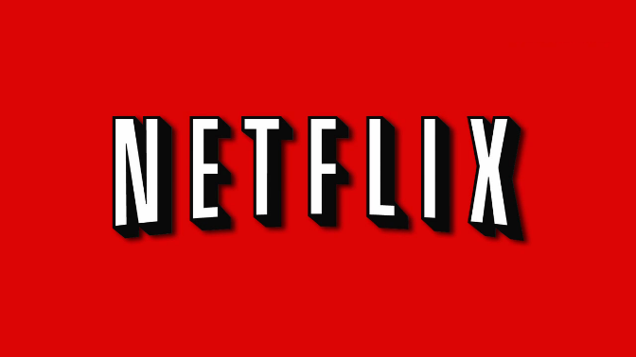

Figure 3. 1 (Ref: https:// wccftech.com/netflix-google-play-account-billing-long/ )

Netflix is the world's leading internet entertainment service with over 117 million members in over 190 countries enjoying more than 140 million hours of TV shows and movies per day, including original series, documentaries and feature films. Members can watch as much as they want, anytime, anywhere, on nearly any internet-connected screen. Members can play, pause and resume watching, all without commercials or commitments.

There are a few things that become the pre-eminent feature of Netflix, and also things into consideration when using the streaming video service.

1. No commercials

Netflix comes with the features without the ads. Watch the entire movie and episodes of users favorites without a single commercial break.

2. Binge watching

Netflix has all the episodes from all series that users want, so users should not feel worried about the end of the episode that hangs.

3. Huge selection

Netflix is equipped with thousands of content/movies from different genres and is available for users to watch, anytime, anywhere. If the user cannot find the desired movie/content, users can request the content/movies in the main page of Netflix sites.

4. Watch anywhere

Netflix is not just for TV. With a Netflix account, users can stream movies through computers, gaming systems, smart phones, tablets, streaming systems, Blu-ray players and more. As long as you have an internet connection, Netflix goes where you go.

5. No commitment

By signing up and pay IDR 39,000/month for as long as users want. The user can cancel Netflix service anytime anywhere without any compensation or penalties.

III.3 The Comparison Between Netflix and Iflix

Iflix is a subscription video-on-demand service focused on emerging markets. Its global headquarters are in Kuala Lumpur, Malaysia. The site serves as a digital hosting and distribution platform for Western, Asian, and Middle Eastern TV shows and movies obtained through partnerships with over 150 studios and content distributors globally.

There are a few things that become more value than Netflix, as for things into consideration when using the streaming video service.

Table 3. 1 Comparison Netflix & Iflix

|  |  |  |
| --- | --- | --- |
| **Comparison** | **Netflix** | **Iflix** |
| 1. Hours of content | Over 30.000 hours of content including Netflix original titles. | Over 20.000 hour of hit movies and TV series including local and Asian content. |
| 1. Maximum Devices per Account | 6 Devices | 5 Devices |
| 1. Simultaneous streaming on multiple devices | 1 device for Basic plan / 2 for Standard plan / 4 for Premium plan | Up to 2 devices |
| 1. Streaming Quality | SD for Basic Plan / HD for Standard / UHD for Premium | Standard definition only |
| 1. Number of Downloadable content | Not Available | Up to 10 videos |
| 1. App availability | Any device with internet connection | Android, IOS, Dekstop, and Web browser |
| 1. Free Trial | 1 Month | 30 Days |
| 1. Starting Price (each month) | IDR 109.000 for Basic plan / IDR 139.000 for Standard / 169.000 for Premium | IDR 39.000 for Standard plan |

* 1. III.4 Target Customer

Target customer is the person you've identified as most likely to purchase your products. Netflix the business to customer or B2C. Which is where the business to customer is a business that sells services directly to customers. Customers can choose what they want to watch. Sites will be sent a notice to the business organization and the organization will send services to customers.

The company’s [target market](http://michaelwessel.weebly.com/uploads/6/8/1/0/6810798/netflix.pdf) includes males and females between the ages of 17-60 and households with income levels of $30,000 and up. With such huge disparity among the people belonging target group, it can easily be inferred that Netflix segments its users based on psychographics and not on demographics.

In terms of psychographics, users are segmented in 3 basic groups :

1. people who are too busy to go out and shop for movies,
2. people who are frequent renters and movie buffs, and
3. people who want to get the most value for their money.

III.5 Revenue Model of Netflix

The primary source of revenue for Netflix is subscriptions. That is, subscribers pay to access content on Netflix and to get DVDs delivered to them and that is how the company makes money.

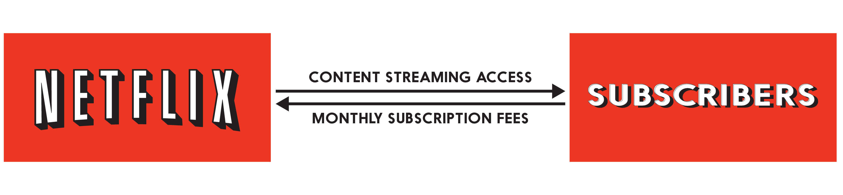

Figure 3. 2 (Ref : https://www.feedough.com/how-does-netflix-make-money/ )

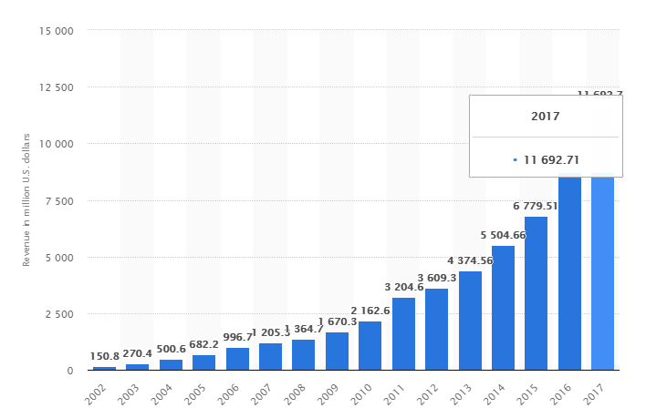

Figure 3. 3 (Ref:https: //www.statista.com/statistics/272545/annual-revenue-of-netflix/ )

This statistic shows the revenue of Netflix from 2002 to 2017. In 2008, the total revenue of the video streaming site amounted to around 1.36 billion U.S. dollars and grew to 11.69 billion U.S. dollars in 2017. The American media company's net income in 2016 stood at 558.93 million U.S. dollars, with a total of 5,500 employees working at the company worldwide.

* 1. III.6 Advantages and Disadvantages of Netflix

There are several advantages and disadvantages that can also be considered, such as the following :

Table 3. 2 Advantages dan Disadvantages Netflix

|  |  |
| --- | --- |
| Advantages | Disadvantages |
| * Simple and easy to use * No commercials * Original program * You can download the content and watch it offline * Different membership plans * It is affordable * Fantastic experience | * The new content is not available right away * Outdated library * Selection depends on your location |

CHAPTER IV

CONCLUSION AND SUGGESTION

* 1. IV.1 Conclusion

Netflix is one of the e-business technology made in terms of support high mobility technology. Netflix is a service used to stream movies online as well as offline-based, it's easy and practical but the absence of age restriction to access the video. By way of setting up internet data and already subscribe, if you want the offline users must download the movie and has already subscribe. Netflix service benefit by way of customer subscription each month. Netflix service into e-business type B2C because Netflix provides services directly to users.

* 1. IV.2 Suggestion

This application is very helpful for people who are lazy waiting in line at the movies, very practical and more efficient time in filling leisure time by using the streaming video service online.Users can more easily find the movies you want, but there is no age restriction feature given that users from different ages.

Netflix is highly recommended for all people to fill spare time so there is no need to go to the cinema to watch the movie.

# **Bibliography**

Amalia, E. I. (2016, January 07). *MetroTV News*. Retrieved from teknologi.metrotvnews.com: http://www.teknologi.metrotvnews.com

*BBC Uk*. (2018, January 23). Retrieved from BBC.co.uk: http://www.bbc.co.uk

*Forbes*. (n.d.). Retrieved from Forbes.com: http://www.forbes.com

Rahman, A. F. (2016, April 15). *detikinet*. Retrieved from inet.detik.com: http://www.inet.detik.com